**Training Data Set Creation**

The training data set used for this analysis is shown below (first 5 lines):  
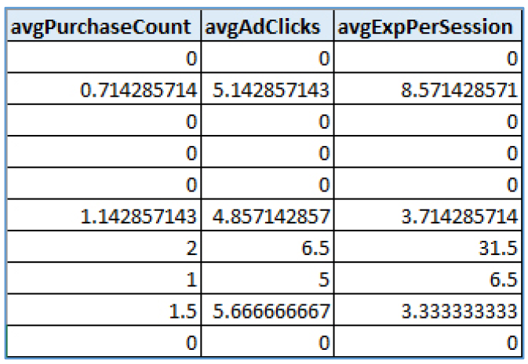

Dimensions of the training data set (rows x columns) : 1091 rows x 3 columns

# of clusters created: 3